Session plan for Walk-of-Life

Aim
The aim of this simulation is to create awareness of how it feels to be unequally treated depending on your gender, nationality/race, and sexuality.

Format
1,5 day long simulation about social inclusion.
The exercise start by giving the participants role cards, for ex. “homosexual European male”, heterosexual African female”, or “asexual Asian male”. The participants get time to get into their role: create a name and personality, and interact with each other in the new roles, for ex. by a bone fire evening or some other social evening activity. The actual simulation start the next morning and take place mainly during a long walk. During the simulation the participants complete various stages of life from birth to death. The stations along the path are related to education, work, marriage, having children, crossing borders and going to elderly care. All participants pass the same stations, but outcomes will be different depending on their gender, nationality/race, and sexuality.

Route
The simulation should preferably be done along an at least 10 km long path in the nature. In Guardians of Equality we did it at a 12 long forest path in Inari, Finland. The route started from a parking lot shown at the left bottom corner of the map. Participants are transported to the starting point with a mini bus in 2-3 turns. The route ends at the course centre. As a result of the unfair conditions, some participants had to return to some stations several times, which meant that they walked nearly double the distance.
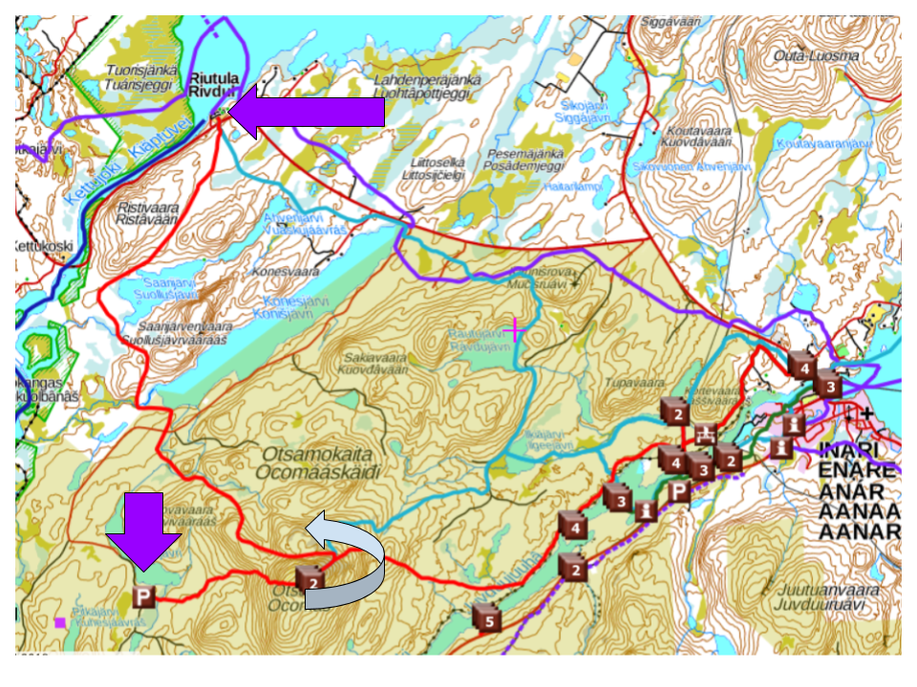

STATIONS DURING THE SIMULATION

1. Waking up
Different awakening times, we can’t decide when we are born, where we are born and whom our parents will be,
First group will wake up at 5:00, 10 participants
Second group: 5:30 - 10 participants
Third group 6:00 - 10 participants
Fourth group 6:30 - 10 participants

2. Breakfast and departure to life path
7-8 am
Sending out participants - busses filled randomly

3. Education
Different tests for different people, tests are done individually (they can’t help each other):
person | test marked with
woman | W
man | M
black woman | BW
black man | BM

Tests are checked, 0/1 points per question. Right answers:
- B) potassium / kalium
- A) x=6
- B) Sofia
- B) density of wood is smaller than density of water / Puun tiheys on pienempi kuin veden tiheys
- B) Spain / Espanja
- A) 140 EUR
grading: grade marked into name tag
points | grade
5-6 | A
3-5 | B
0-2 | C

4. Work

Black people need to sit and wait (15 minutes)
Salary handed according to the table below (marked into the name tag or monopoly money) A, B, C are grades they received in exams
 | A | B | C
general | 75 | 50 | 25
men | 100 | 75 | 50
women | 50 | 25 | 25
gay or lesbian | 25 | 25 | 25

Those who come back, earn 50€ on their second time
Men and returning A-student women, will be able to pay for rent, food and snack.

5. Life expenses
Participants need to pay to be able to cross, and to pay for food, 100$
White heterosexual men are coming with maximum
Rent: 50€
Food: 25€
Snack: 25€

6. Family
During lunch – they need to pair up, they will start up a family
Comp score:
same race +1 / 0
matching sexuality +1 / 0
matching gender +1 / 0
single -3

Score marked on tag

Egg according to comp. score
+3 wooden egg
+2 hard boiled egg
+1 raw egg
0 raw egg on a spoon

7. Medical assistants
Gay = Needs to go to hospital to be tested for STDs wait for 15 min before they can go further

Medicin - fruits and water to refill bottles with (they all look sick after a lot of walking – so will make sure they have some fruits and water!)

Getting money depending on what the egg looks like:
Fine egg: 100€
Crack in the egg: 75€
Broken: 50€
No egg: 0€

8. Travel, Boarder control
We are going to ask them questions:
Are you gay?
Are you married?
Are you going to commit gay acts?

* White people will pass without questions and without paying anything
* Pay – black person married with a white person – 50€

* Black couples – if they have 100€ they can pay and pass, otherwise wait for 15 minutes and pay 25$ per person and then pass

* Gay people, if they lie (don´t admit they are gay) they have the same rules like everyone else.
If they tell they are gay they have to pay 150€ they don’t have enough money – wait for 30 minutes.
Option: They can try to cross the boarder illegally.

9. Life, Elderly care - at the venue
Three or Four circles (10 participants pr. circle)
Cirkel 1 - Best ones, with snacks (fruits and candy) and drinks - for the first one to arrive
Cirkel 2 - fruits and drinks
Cirkel 3 / 4 - drinks

- Debriefing
Debriefing.

The same afternoon/evening: small groups right after + notes

Discussion in bigger group next morning

How was it? What did you notice during the day?
Do you have any idea about why some needed to wake up earlier?
Why do you think we did this?
Did you notice anything about the test?
Did you notice anything when we handed out the egg?

MATERIALS NEEDED:
Stickers
Monopoly money/made money
Eggs of various type
Permanent markers
Pencils
School exams printed
Spoons
Lunch packages + snacks
Role tags
Snacks for elderly care station
Mini bus

SCHOOL EXAMS/ TESTS

EXAM W

- What element is chemical symbol K used for?

- Solve equation 5x+3=3x+15 for x.

- What is the capital city of Bulgaria?

- Why does wood float on water?

- What is the home country of the airline Iberia?

- Smart phone with price of 200 euro is sold with 30 % discount. What is the price that needs to be paid?

EXAM BW

- Minkä alkuaineen kemiallinen merkki on K?

- Ratkaise yhtälö 5x+3=3x+15.

- Mikä on Bulgarian pääkaupunki?

- Miksi puu kelluu vedessä?

- Mistä maasta tulee lentoyhtiö Iberia?

- Saat 200 euron älypuhelimesta 30 % alennuksen. Paljonko sinun pitää maksaa puhelimesta?

EXAM M

- What element is chemical symbol K used for?
  - Calsium
  - Potassium
  - Chlorine

- Solve equation 5x+3=3x+15 for x.
  - x=6
  - x=12
  - x=3

- What is the capital city of Bulgaria?
  - Bukarest
  - Sofia
  - Belgrad

- Why does wood float on water?
  - Density of wood is greater than density of water
  - Density of wood is smaller than density of water
  - Density of wood is equal to density of water

- What is the home country of the airline Iberia?
  - Italy
  - Spain
  - France

- Smart phone with price of 200 euro is sold with 30 % discount. What is the price that needs to be paid?
  - 140 EUR
  - 170 EUR
  - 100 EUR

EXAM BM

- Minkä alkuaineen kemiallinen merkki on K?
  - kalsium
  - kalium
  - kloori

- Ratkaise yhtälö 5x+3=3x+15.
  - x=6
  - x=12
  - x=3

- Mikä on Bulgarian pääkaupunki?
  - Bukarest
  - Sofia
  - Belgrad

- Miksi puu kelluu vedessä?
  - Puun tiheys on suurempi kuin veden tiheys.
  - Puun tiehys on pienempi kuin veden tiheys.
  - Puun tiheys on yhtä suuri kuin veden tiheys.

- Mistä maasta tulee lentoyhtiö Iberia?
  - Italia
  - Espanja
  - Ranska

- Saat 200 euron älypuhelimesta 30 % alennuksen. Paljonko sinun pitää maksaa puhelimesta?
  - 140 EUR
  - 170 EUR
  - 100 EUR

